Dear Amazon
Thanks for your concern about our account. We are so sorry for the problem of:
Create misused ASIN variations repeatedly or impacted customer trust through the usage of incorrect variations.
To sell on Amazon.com, we have set a plan that explains how we will follow this policy. We know that seller has obligation to make sure the product detail pages create are compliant with Amazon’s policies. Here is our plan of action that explains:
-- Detail on the root cause(s) of the policy violation
>>>>>>Detail on the root cause(s) of the policy violation
- The negligence of platform policy training resulted in the staff don't have enough knowledge about the Variation relationships and ASIN creation policy:
-- ASIN: BXXXXXXXX7, BXXXXXXXX5, BXXXXXXXX6, BXXXXXXXXP, BXXXXXXXXW
--违规原因: 变体关系操控

Due to our staff don't have enough knowledge about the Variation relationships and ASIN creation policy, they list different products together, we check all 4 Asin's detail and know that:
BXXXXXXXXW: LISTING 标题 (White) （附图FLUS-AMJK4310-DF3C）

产品图片截图
BXXXXXXXX6：LISTING 标题 (Blue)（附图FLUS-AMJK3905-DF3C）

产品图片截图
Although these two products are called “THERMOMETER”, but they are totaly different ,and cannot be etablish together by variation for color.

In addition，for gain more product views and more product session percentage, our staff establish two Asin from UK market：BXXXXXXXX5 & BXXXXXXXXP under Parent Asin BXXXXXXXX7 as a parent-child variant relationship for share its comments:
https://www.amazon.de/dp/BXXXXXXXXP
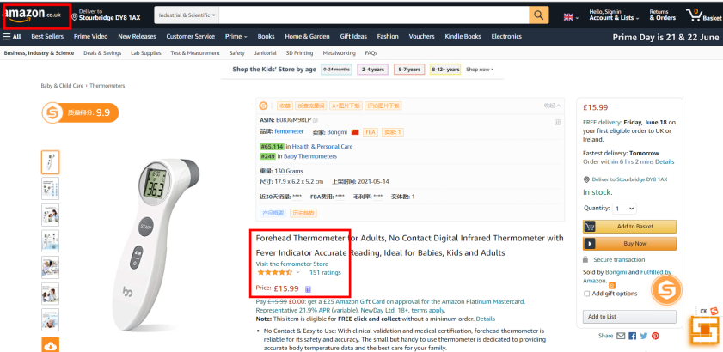

-- ASIN: BXXXXXXXXT, BXXXXXXXX1, BXXXXXXXX1, BXXXXXXXXG, BXXXXXXXXK
--违规原因: 变体关系操控

For the same raison of the knowledge about the variation relationships not enough, our staff had edit a price and stockage for the parent asin:BXXXXXXXXT, but the parent product is displayed in the search results and used by establish relationships between the child products ,NON-buyable product used to relate child products,
And bind several completely different products together.

BXXXXXXXX1:LISTING 标题 (附图：FLUS_AMJK4002_WXJ2）
产品图片截图
BXXXXXXXX1:LISTING 标题 (Grey）(附图：FLUSAMJK5202-DF）
产品图片截图
BXXXXXXXXG：LISTING 标题（(附图：FLUS_AMJK4301_SZD）
产品图片截图
BXXXXXXXXK：LISTING 标题(附图：FLUS_AMJK4101_SZD）
产品图片截图
After learning those 4 variations , we found , although all those 4 are under the definaion of "thermometers",but with the product appearance and performance are differents ,so we cannot edit those 4 under the same parent as variation
and those listing did not follow the regulation amazon： etablish the same titles and the high similarity product detail page under the same parent Asin.

-- ASIN: BXXXXXXXXX, BXXXXXXXX1
--违规原因: 变体关系操控

Althought the etablish time for asin BXXXXXXXX1 and B0XXXXXXXXX were later than BXXXXXXXXG, and when the relationship of vatiation was etablish, the BXXXXXXXXG was accumulative some comments ,but those two variations asin are exactly same products except the color , we'd like to show your the packaging pictures, product instructions, certification in attachment ，and we kindly request to re-check the details of the parent-child relation and re-judge the violations of the variation（附件加：说明书，两款产品外包装，和所有可以添加的附件， 展示所有类比细节）

附加截图：账号后台asin上架时间截图

BXXXXXXXX1:LISTING 标题(White)
产品图片截图

BXXXXXXXXG:LISTING 标题(Black)
产品图片截图

So in summary, the root cause(s) are:
1. In order to maintain sales, product views and more product session percentage, our staffs don't have enough knowledge about the Variation relationships and ASIN creation policy due to imperfect Amazon policy training.
2.Imperfect monitoring mechanism：The account manager didn’t detect that our staffs create product detail pages with invalid variations because of mismanagement. Our staff do not have a knowledge of product detail and absence of training before creat listing

-- Detail on the actions you have taken to resolve the policy violations
1.Review all listing with parent-child relationship
- We have deleted all the variants that do not meet the policy requirements.
Such us： BXXXXXXXX5 & BXXXXXXXXP
- We have thoroughly rechecked all the products in the store, re-edited the product’s detail page to make sure the title, color, performance, description match each ASIN, and compliant with Amazon’s policies.We would be appreciated if you can take a few minutes to check our selling account.
- We have re-trained all the staff (new and experienced salesman) about the severity of violate Variation relationships and ASIN creation policy. We promise all our staffs have learned the lesson.

- Though we have run business on Amazon for more than two years, we are still in severe lack of the Amazon policies and guidelines. Thus we specially arranged a lecture of the Amazon policies and guidelines for our staffs. We invited a professional Amazon shop runner to hold the lecture for us and asked all of our staffs to attend the lecture. During the lecture, our staffs listened to the lecturer attentively and put forward some impressive question at the end of the lecture. Every question was answered thoroughly by the lecturer. Our staffs learned a lot from this precious lecture.
For the first course, we will train on the following rules：
Policy 1: What are variant relationships?
Policy 2: Elements of variant relationships
Policy 3: What is the father/son relationship?
Policy 4: When to use a parent/child relationship
Policy 5: How do variants appear on the product details page
Policy 6: Delete parent and child goods relationships

3.Punishment measures for account managers：Due to regulatory negligence, those non-compliant parent-child relationship was etablish. We deducted all commissions for those Asins mentioned in the performence notification of the manager, and publicized the punishment statut within the company for Warning .

-- Detail on the steps you have taken to prevent the policy violation going forward
1. We have fired the manager who was responsible for our seller account; our new suitable manager will take up the job within 5 days. This manager is from a company that specialized in foreign trade. He has been working in Amazon since he graduated, we are sure that this new manager will be qualified for the job.
2. We have asked all the staff use inventory files or XML uploads or the Add a Product tool to establish parent-child relationships between products. They will check the inventory file for our specific category to see whether it supports relationships. What’s more, they will always ask themselves the following questions to help to determine whether certain products are valid variations:
*Are the products fundamentally the same?
*Do the products vary only in a few specific ways?
*Would customers expect to find these products together on a single product detail page?
*Could the products share the same title?
3. And then we will set up a new department with 4 staff, variation inspection Department, all of them have more than 3 years’ experiences on Amazon and also has deep and up-to-date knowledge of ASIN Creation Policy and ASIN variation Policy, they will detect that whether our staff follow the following requirements when creating variations:
*Describe each child product fully, so they will be included in *browse and search
*Add the appropriate variation value to the product title
Use SKUs to build relationships using field for SKU and parent SKU
*List the child offers in the parent SKU in the flat-file or XML
*Do not create variation families or add children to variation families that are not the same brand or product type
* Do not add or create an Item Package Quantity variation (multi-pack) that was not created by the manufacturer
* Do not include price and quantity value for the parent products
*Do not include variation value in the parent title
* Do not choose a variation theme other than what is listed in the approved theme for each product type
* Do not list different products together
* Do not put more than one product characteristic in a variation attribute
4. We have arranged one staff to regular check all listings on amazon every day to avoid the same violation in the future. Only when the variation relationship listings allow buyers to compare and choose products based on different attributes such as size, color, or other characteristics from the available options on a single product detail page, then it can list on Amazon. We will calculate the accuracy of their inspection into their KPI examine, for example, if one employee didn't detect the invalid variations, he will be punishment, if the error appears more than 3 times, then he will be fired.
5. We will train our staff once a month; we require them to study Amazon selling policies comprehensively, especially Variation relationships, ASIN creation policy, so they can comprehend all amazon updated policy in timely manner.
6. For new employees, we have made a rule: we will train our new employees, we will give a test to them before they join our company, and once they violate amazon policies, and we will fire them immediately.
7. In order to help all the staff have a clearly understand of ASIN variations, we have gathered more than 100 examples of good and bad variations and make it into booklet. Here is a part of it:
*Examples of bad variations:
Individual bath gel, shampoo, and scented powder (separate SKUs) that are the same scent
Short sleeve and long sleeve t-shirts by the same manufacturer
*Examples of good variation families are:
Items of clothing that come in different sizes (small, medium, large)
Items that come in different colors (blue, red, black)
8. Now all the employees have realized the seriousness of misused ASIN variations. They are very cooperated with us and promise to behave correctly, they have also recognized that comply with Amazon policies are essential for survival in an intensely competitive market. They will never
*Adding child products that are not true variations of the parent product.
* Changing the parent product’s detail page so it does not match the child ASINs.
We will always keep in mind to matching our products to existing products in Amazon’s catalog and caret good Parent-child relationships to helps drive a high-quality customer experience.
Thank you for providing us a wonderful platform where we can reach thousands of customers, we are willing to do every endeavor to sell on amazon.com again.
Can you give us one more chance?
Yours,
店铺名

